9.1 Right Triangle Trigonometry

|  |
| --- |
| What is trigonometry?  Trigonometry is a branch of mathematics that studies relationships involving lengths and angles of triangles. |
| Commonly Used Greek Letters in Trigonometry Used to Represent Angle Measures: |
| SOHCAHTOA   |  |  | | --- | --- | |  |  | |
| Reciprocal Trigonometric Ratios |
| ex: Find all trigonometric functions of theta. |
| ex: Let  be an acute angle of a right triangle. If  find the other trigonometric functions of theta. |
| Common Pythagorean Triplets   |  |  | | --- | --- | | 3 - 4 - 5  5 - 12 - 13  5 - 15 - 17  7 - 24 - 25 | Memorize these! | |
| CALC ex: Solve |
| Vocabulary   |  |  | | --- | --- | | * angle of elevation - the angle between one's line of sight and the horizontal | * angle of depression - the angle between one's line of sight and the horizontal | |
| Ex: What conclusion can be made about the angles of elevation and depression? |
| CALC ex: A parasailer is attached to a boat with a rope 300 feet long. The angle of elevation from the boat to the parasailer is 488. Estimate the parasailer’s height above the boat. |
| CALC ex: If a plane that is cruising at an altitude of 30,000 ft wants to land safely it must begin its descent so that the angle of depression to the airport is 7°.   |  |  | | --- | --- | | a) How many miles from the airport must the plane begin descending? | b) How many miles will the plane travel before landing? | |

**Notes: 9.2 Define general angles and use radian measure**

|  |  |
| --- | --- |
| Macintosh HD:Users:teacher:Desktop:Screen shot 2016-02-29 at 5.22.46 PM.png  Rotations counter-clockwise: positive Rotations clockwise: negative | |
| Example 1: Draw an angle with the given measure in standard position.   |  |  |  | | --- | --- | --- | | a. | b. | c. | | |
| **Definition of coterminal angles:** angles where the terminal sides coincide.  *To find a coterminal angle, add or subtract multiples of 360o.  Example 2: Find one positive and one negative coterminal angle for 140o.   |  |  | | --- | --- | | a. | b. | | |
| Angles can also be measured in radians. One radian is the measure of an angle in standard position whose terminal side intercepts an arc of length r.  Because the circumference of a circle is , there are radians in a full circle. Therefore:  radians and  radians | Macintosh HD:Users:teacher:Desktop:Screen shot 2016-02-29 at 5.36.36 PM.png |

|  |  |  |
| --- | --- | --- |
| Converting Between Degrees and Radians   |  |  | | --- | --- | | Degrees to Radians | Radians to Degrees | |
| Ex 3: Convert from degrees to radians. Ex 4: Convert from radians to degrees.   |  |  | | --- | --- | |  |  | |
| Macintosh HD:Users:teacher:Desktop:Screen shot 2016-02-29 at 5.44.31 PM.png |
| Example 5: Find the arc length and area of a sector given r = 3 cm and central angle .   |  |  | | --- | --- | | arc length | area | |
| Example 6: Use a calculator to evaluate the trigonometric expression. Round to 3 decimal places.   |  |  |  |  | | --- | --- | --- | --- | |  |  |  |  | |
| **General Definition of the Trigonometric Functions**   |  |  | | --- | --- | |  |  | |
| ex: Let (-4, 3) be a point on the terminal side of an angle, theta. Evaluate the six trigonometric functions of theta.   |  |  | | --- | --- | |  |  | |
| **The Unit Circle**  The unit circle is a circle centered at the origin with a radius of one unit.   |  |  | | --- | --- | |  |  | |

**9.3 Evaluating Trigonometric Expressions**

|  |  |  |
| --- | --- | --- |
| ex: Let (-1, -2) be a point on the terminal side of an angle, theta. Evaluate the six trigonometric functions of theta.   |  |  | | --- | --- | |  |  | |
| **REVIEW: The Unit Circle**   |  |  |  |  |  |  | | --- | --- | --- | --- | --- | --- | |  |  |  |  |  |  | |
| **Quadrantal Angles**  A quadrantal angle is an angle in standard position whose terminal side lies on an axis. |
| ex: List the quadrantal angles on the indicated interval.   |  |  | | --- | --- | | a) | b) | |
| ex: Evaluate.   |  |  |  |  |  |  |  |  |  |  |  |  | | --- | --- | --- | --- | --- | --- | --- | --- | --- | --- | --- | --- | | Macintosh HD:Users:teacher:Desktop:Screen Shot 2018-05-15 at 12.41.17 PM.png | |  |  | | --- | --- | |  |  | |  |  | |  |  | |  |  | |  |  | | |
| **Signs of Trigonometric Functions**  ex: Determine which trigonometric functions are positive in each quadrant.   |  |  | | --- | --- | |  |  | |
| ex: In what quadrant is...   |  |  | | --- | --- | | a) | b) | |
| ex: Determine the sign of each quantity.   |  |  |  |  | | --- | --- | --- | --- | | a) | b) | c) | d) | |
| **Reference Angle**   |  |  | | --- | --- | |  | Let  be an angle in standard position. The reference angle for  is the acute angle  formed by the terminal side of  and the closest x-axis. | |
| ex: Find the reference angle.   |  |  |  |  | | --- | --- | --- | --- | | a) | b) | c) | d) | | e) | f) | g) | h) | |

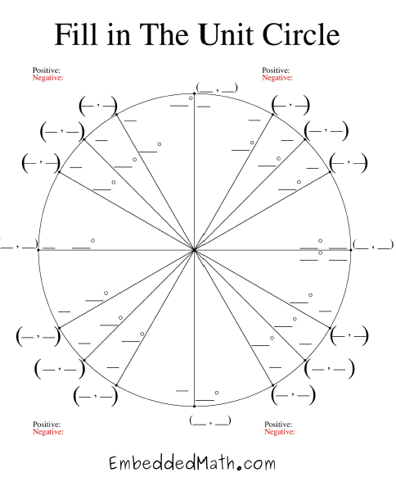

10.1/10.2 Sine and Cosine Curves

|  |  |  |  |  |  |  |  |  |  |  |  |  |  |  |  |
| --- | --- | --- | --- | --- | --- | --- | --- | --- | --- | --- | --- | --- | --- | --- | --- |
| **Parent Function: Sine**     |  |  |  |  |  |  |  |  |  |  |  |  |  |  |  | | --- | --- | --- | --- | --- | --- | --- | --- | --- | --- | --- | --- | --- | --- | --- | | |  |  | | --- | --- | | x | y | | 0 |  | |  |  | |  |  | |  |  | |  |  | |  | Domain:  Range:  Symmetry:  Even/Odd/Neither:  Period:  Pattern: | |
| **Parent Function: Cosine**     |  |  |  |  |  |  |  |  |  |  |  |  |  |  |  | | --- | --- | --- | --- | --- | --- | --- | --- | --- | --- | --- | --- | --- | --- | --- | | |  |  | | --- | --- | | x | y | | 0 |  | |  |  | |  |  | |  |  | |  |  | |  | Domain:  Range:  Symmetry:  Even/Odd/Neither:  Period:  Pattern: | |